VINTAGE 2019 - With vintage 849 an exciting year, for us and the entire team, is now coming to an end. In Austria we are reckoning 2019 as a typical 9’er vintage and is in terms of structure and balance one that could be compared to the legendary 1999.
The year started dry with only 20mm precipitation until the beginning of May. In consequence we had a delayed bud break, which diminished the danger of spring frost. The needed water came in May and leaded to a fast beginning of the vegetation period. One of the most significant differences between 2018 and 2019 was the fact that – in contrary to 2018 – average temperatures from June on are starting to decrease. (see also last Xmas letter … for 2019: June 23,3°, July 22°, August 21,5°) This fact resolved in a very good acidity structure. Water supply was enough to avoid dry stress. In the beginning of September, we got 70mm which cumulates to 320mm for the year until the beginning of harvest. From then on it was only dry and beautiful harvest weather.
We started in the second week of September with the grapes for our Brut Reserve, Blanc de Blancs and the Brut Rosé. In the fourth week of September we started with the red wines and soon after with white grapes for the regional wines. In the mid of October, we began picking the single vineyard wines, and finished with them on 29th of October.
For us - 2019 will be remembered as the vintage with the lowest selection necessity and effort. Everything was perfectly healthy.

Precipitation Average Temp Max Temp Min Temp
Jän 5 0 13 -10
Feb 2,29 3 19 -8
Mär 12,19 7 23 -3
Apr 0 11,4 27 -0,1
Mai 108 12,8 25,8 0,8
Juni 30 23,3 37 12,2
July 41,4 22 39,8 9,4
Aug 42,67 21,5 36,8 9,6
Sep 80 16,1 29 2,6
Okt 26,4 10,9 26 -1

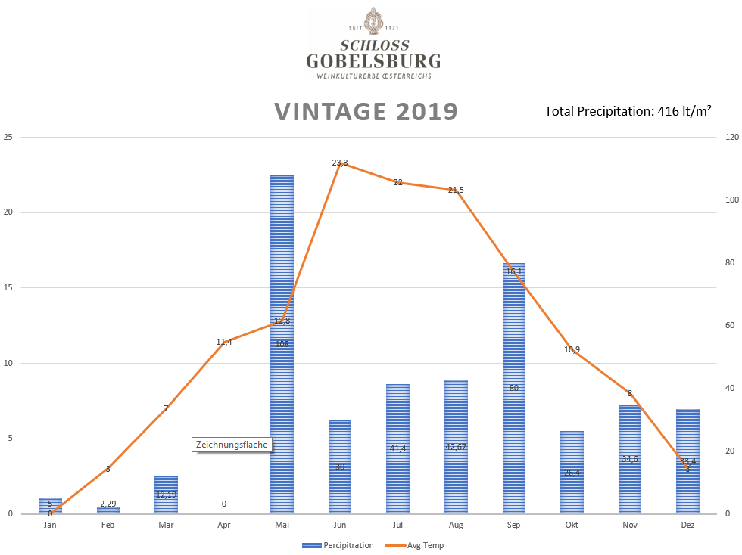
47 hl/ha

