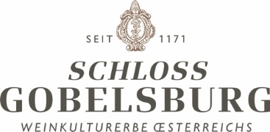

VINTAGE 2018 - From the prospective of statistics the year could be defined as an average one. Even though the year was subjectively seen as a hot and dry one, this is not reflected in climatically data and records. Temperatures as well as precipitation were in general average. The most influential factor for the vintage was the lack of spring time. In the third week of April we experienced a temperature shift from very cold in the beginning of April to more than 20°C. And it continued like that. The effect was that nature developed in fast motion and everything seemed to blossom at the same time – it was a spectacle. Also in the vineyards you could watch the shoots grow and the first weeks in the vegetation period were a big challenge for the whole team. However, summer remained with average temperatures (June 21°, July 22°, August 23°). Until the beginning of September, we got 478mm of rain, which is already an average level for a year. But all this has been leading to a very early maturation, because normally in Spring time we have a delayed development because temperatures are not that high.
So, Harvest started in the third week of August with the grapes for our Brut Reserve and the Blanc the Blancs. In the third week of September we started with the red wines and soon after with grapes for the regional wines. Second week of October we started with the single vineyard wines and finishing of on the 24th of October. All in all, 7 to 10 days earlier than in 2003, which happened to be our earliest vintage so far. Ice-wine was harvested on the 22nd of January.

Precipitation Average Temp Max Temp Min Temp
Jän 16 3,1 16,3 -3,8
Feb 16 -0,5 8,6 -13
Mär 42 2,9 15 2,9
Apr 18 15,3 29,7 -0,7
Mai 115 18 30,3 8,4
Juni 47 20,8 35,1 7,6
July 87 21,9 36,4 6,8
Aug 34 23,2 36,6 6,8
Sep 94 16,7 31,1 0
Okt 7,4 12,3 24,8 1,9

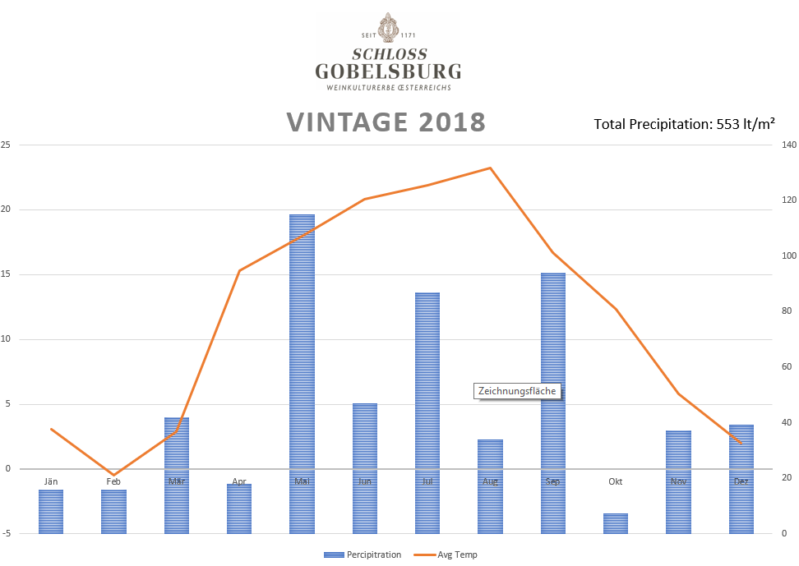
64 hl/ha

